The Bamiyan Colossi, the Garden of Eden, and the Bridge of Judgment: A Comparative Study of Sacred Narratives from the Avesta to the Qur'an
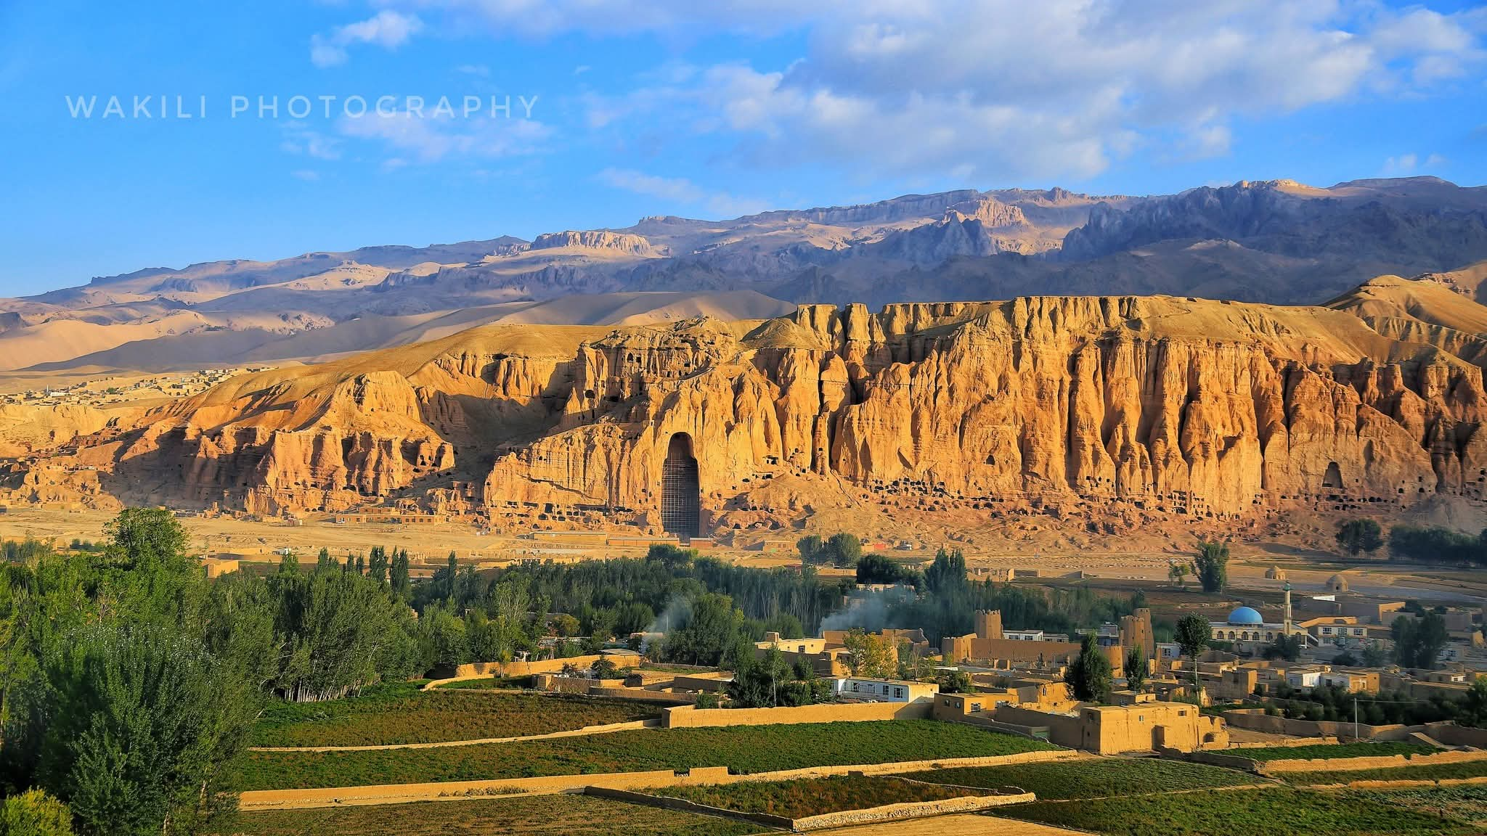
Abstract

This paper examines the Bamiyan Colossi—the giant Buddha statues destroyed in 2001—through the lens of comparative religious narrative. It traces the transformation of these sculptures from Buddhist icons to figures integrated into Islamic mythic history, where they were reimagined as the legendary figures Salsal and Shamama, and associated with Adam and Eve. The paper then establishes a deeper connection: the Zoroastrian concepts of heaven (Garodeman), hell (Drujodeman), and the Chinvat Bridge—all of which originated in the Avestan sacred geography of the Bamiyan region—were later adopted and transformed into the Islamic paradise (Jannah), hell (Jahannam), and the bridge of As-Sirāt. Drawing on textual evidence from the Avesta, the Gathas, the Torah, the Gospels, the Qur'an, and the Shahnameh, this study argues that the core eschatological framework of the Abrahamic religions has its roots in the eastern Iranian world, specifically in the sacred landscape of Bamiyan and the Helmand basin.

---

1. Introduction: The Sacred Landscape of Bamiyan

The Bamiyan Valley in central Afghanistan is one of the most significant cultural and religious sites in the ancient world. Located at the crossroads of the Silk Road, it served as a meeting point for Buddhist, Zoroastrian, and later Islamic civilizations. The valley is home to the remnants of the colossal Buddha statues—the western figure standing 55 metres tall and the eastern figure 38 metres tall—carved into the cliffs between the late sixth and early seventh centuries CE. These statues, however, are not merely Buddhist monuments; they have been reinterpreted and integrated into the mythic history of the region across multiple religious traditions.

This paper explores three interconnected themes:

1. The reimagining of the Bamiyan Buddhas in Islamic tradition as the figures Salsal and Shamama, and their association with Adam and Eve.
2. The Zoroastrian origins of heaven, hell, and the Bridge of Judgment (Chinvat Bridge) in the Avesta, and their geographical anchoring in the Bamiyan-Helmand region.
3. The transmission of these concepts into Judaism, Christianity, and Islam, demonstrating that the eschatological framework of the Abrahamic religions—paradise, hell, and the bridge of judgment—has its roots in the ancient Iranian world.

---

2. The Bamiyan Colossi in Islamic Tradition: Salsal, Shamama, and Adam and Eve

2.1 The Buddhist Origins

The Bamiyan Buddhas were created as Buddhist devotional images, representing the enlightened Buddha in a standing posture. The statues were adorned with copper-alloy face masks and arm coverings, which were removed when the Buddhist community migrated from Bamiyan by the tenth century CE. Without these facial features, the statues took on a strange, awe-inspiring appearance that invited new interpretations.

2.2 The Islamic Reinterpretation: Salsal and Shamama

By the eighteenth century, the Colossi had been fully integrated into the mythic history of the Islamization of Bamiyan. Local legends recorded in the early twentieth century reveal that while "the whole world knows that the two colossi represent Buddhas, the inhabitants of Bamiyan are not of our opinion". Instead, they reinterpreted the statues through the lens of Islamic tradition.

The larger, western statue (55 metres) was known as Salsal, and the smaller, eastern statue (38 metres) was called Shamama (also recorded as Shahmama). According to local Islamic legend, Salsal was a legendary warrior from the distant past who was converted to Islam by Hazrat-i Ali, the fourth Caliph, and Shamama (or Shahmama) was his wife. This narrative transformed the Buddhist statues into heroes of the Islamic conversion story, embedding them within the sacred history of the region.

The names themselves carry profound significance:

· Salsal means "the light shines through the universe".
· Shamama (or Shahmama) means "Queen Mother".

2.3 The Adam and Eve Connection: The Qur'anic "Salsal"

The name "Salsal" is particularly significant. The Qur'an, in Surah Al-Hijr (15:26), uses the word "Salsal" (صَلْصَال) to describe the material from which Adam was created:

"And certainly did We create man from sounding clay, from aged clay" (Qur'an 15:26)

The term Salsal refers to "dried clay" or "potter's clay"—the substance from which Adam, the first man, was formed. This is not a coincidence: the local Islamic tradition in Bamiyan, when confronted with the two colossal statues, reinterpreted them using Qur'anic vocabulary. The larger statue (Salsal) became the symbol of Adam—the man created from dried clay—and the smaller statue (Shamama) became the symbol of Eve—the feminine counterpart.

The expulsion from paradise is a central event in the Qur'anic narrative: "O children of Adam, let not Satan tempt you as he removed your parents from Paradise, stripping them of their clothing to show them their private parts" (Qur'an 7:27). The integration of the Bamiyan Colossi into this narrative—with Salsal representing Adam and Shamama representing Eve—demonstrates how local Islamic traditions reinterpreted pre-Islamic monuments to align with their own sacred history.

---

3. Bamiyan in the Shahnameh: The Epic's Witness to Sacred Geography

3.1 Ferdowsi's Recognition of Bamiyan

The Shahnameh, the Persian national epic composed by Ferdowsi between c. 977 and 1010 CE, explicitly mentions Bamiyan as a significant location within the Iranian world. In the epic, Bamiyan is described as the frontier of Iran and the seat of the Kayanian kings:

"Digar Panj-hir u dar Bamiyan / Sar-e marz-e Iran u ja-ye Kiyan"
("And Panjhir and the gate of Bamiyan / The frontier of Iran and the seat of the Kayans")

This verse places Bamiyan at the border of the Iranian world, identifying it as a land of royal and sacred significance.

3.2 Bamiyan, Zohak, and the Epic of Iranian Kings

Other sources note that Bamiyan is associated with the legendary figure of Zohak (Zahhak). The city of Zohak and the cave of Fereydun are located in Bamiyan, linking the valley to the foundational myths of Iranian kingship. The Shahnameh thus provides a crucial Iranian epic witness to the sacred importance of Bamiyan—a witness that predates and complements the Islamic and Buddhist traditions.

3.3 The Shahnameh as a Bridge

The Shahnameh serves as a crucial bridge between the Avestan and Islamic worlds. It preserves the memory of Bamiyan as a sacred landscape while also transmitting the epic traditions of the Iranian world—traditions that share deep roots with the Avestan concepts of heaven, hell, and judgment. When Ferdowsi speaks of "the seat of the Kayans," he is invoking a world that includes the sacred geography of the Avesta, where the Chinvat Bridge and the concepts of Garodeman (heaven) and Drujodeman (hell) were first articulated.

---

4. The Zoroastrian Origins of Heaven, Hell, and the Bridge of Judgment

4.1 Garodeman and Drujodeman: Heaven and Hell in the Avesta

The Avesta, the sacred scripture of Zoroastrianism, contains the earliest known systematic description of heaven and hell in any religious tradition. The Zoroastrian prophet Zarathushtra, in the Gathas (the oldest hymns of the Avesta), clearly articulated the belief in a heavenly abode and a place of punishment.

· Heaven is called Garodeman (Old Avestan: garo demane), meaning the "House of Song" or "House of Hymns." It is described as "a magnificent palace, well built, beautifully constructed, brilliantly illumined, and richly decorated." The righteous souls who enter Garodeman are united with Ahura Mazda in a state of eternal bliss.
· Hell is called Drujodeman (Old Avestan: drujo demane), meaning the "House of Lies" or "House of Destruction." It is the abode of utter darkness, a place of torment presided over by the forces of evil.

This dualistic framework—heaven as the realm of truth and light, hell as the realm of lies and darkness—is the foundation of Zoroastrian eschatology.

4.2 The Chinvat Bridge: The Bridge of Judgment

Central to Zoroastrian eschatology is the Chinvat Bridge (Avestan: Cinvatô Peretûm), the "Bridge of Judgment." All souls must cross this bridge after death. The bridge's appearance depends on the righteousness of the soul:

· For the righteous, the bridge becomes "wide as the broadest shield," allowing the soul to cross easily into Garodeman (heaven).
· For the wicked, the bridge becomes "thin as a hair" or "narrow as a blade," and the soul falls into Drujodeman (hell).

The bridge is guarded by two four-eyed dogs and is overseen by three divinities: Sraosha (Conscience), Mithra (Covenant), and Rashnu (Justice). On the fourth day after death, the soul is judged at the Chinvat Bridge. A beautiful maiden, the personification of the soul's own conscience (Daena), leads the righteous across the bridge, while an ugly woman plunges the wicked into hell.

4.3 The Sacred Geography of the Chinvat Bridge

The Chinvat Bridge and the associated concepts of heaven and hell are not abstract ideas; they are anchored in the sacred geography of the Avestan world. The Bundahišn, the Zoroastrian book of creation, describes the bridge as part of the cosmic landscape centred on the sacred mountain Harā Bərəzaitī—identified with the Koh-i Baba range in central Afghanistan, the source of the Helmand River. This region is the heart of the Avestan homeland, Airyanem Vaejah, which modern scholarship, following the work of Michael Witzel and Gherardo Gnoli, places in the central highlands of Afghanistan—the historical homeland of the Āzrah (Hazara) people.

---

5. The Transmission of Concepts: From the Avesta to the Abrahamic Religions

5.1 The Chinvat Bridge and As-Sirāt

The Islamic concept of As-Sirāt, the bridge that every soul must cross on the Day of Judgment, is directly parallel to the Zoroastrian Chinvat Bridge. In Islamic tradition, As-Sirāt is described as "sharper than a sword and thinner than a hair," and the righteous cross it swiftly while the wicked fall into Jahannam (hell). This concept, like the Zoroastrian Chinvat Bridge, is a sifting bridge that separates the righteous from the wicked based on their deeds in life.

The similarities are not coincidental. The Zoroastrian Chinvat Bridge predates Islam by more than a millennium and was transmitted to the Abrahamic traditions through two primary channels:

1. The Babylonian Exile (6th century BCE): Jewish elites were exposed to Zoroastrian concepts during their captivity in Babylon, and these ideas were incorporated into later Jewish eschatology.
2. The Arab Conquest of Persia (7th century CE): The Islamic tradition, emerging in a cultural environment already exposed to Judaism and Christianity, directly absorbed Zoroastrian concepts through the conquest of the Sasanian Empire.

5.2 Garodeman and Jannah; Drujodeman and Jahannam

The Zoroastrian concepts of Garodeman (House of Song) and Drujodeman (House of Lies) are reflected in the Islamic concepts of Jannah (Paradise) and Jahannam (Hell). The Qur'an describes paradise as a garden of bliss, and hell as a place of fire and torment. These descriptions, while developed in their own right, are built upon a framework that originated in the Avesta.

5.3 The Adam and Eve Narrative: From Eden to Expulsion

The narrative of Adam and Eve, while central to Judaism, Christianity, and Islam, has roots that extend beyond the Abrahamic traditions. The Torah (Genesis 2-3) describes the creation of Adam and Eve, their placement in the Garden of Eden, their disobedience, and their expulsion. The Qur'an recounts a similar story, with Adam and Eve being settled in paradise, tempted by Satan, and expelled.

However, the concept of a "garden of paradise" and the expulsion of the first humans from it is not unique to the Abrahamic traditions. The Zoroastrian tradition contains its own narratives of the primordial human, Gayō Marətan (Kayumars), who was created by Ahura Mazda and later fell from grace. The integration of the Bamiyan Colossi into Islamic tradition as representations of Adam and Eve (Salsal and Shamama) demonstrates how the local sacred landscape was reinterpreted to fit the Abrahamic narrative.

---

6. Conclusion: The Bamiyan Valley as the Cradle of Eschatological Thought

The evidence presented in this paper demonstrates that the Bamiyan Valley—and the broader Helmand basin—was not only a centre of Buddhist art and culture but also the cradle of foundational eschatological concepts that would shape the Abrahamic religions.

1. The Zoroastrian framework of heaven (Garodeman), hell (Drujodeman), and the Bridge of Judgment (Chinvat Bridge) originated in the Avestan sacred geography of the eastern Iranian world, specifically the region identified by modern scholarship as Airyanem Vaejah—the central highlands of Afghanistan.
2. These concepts were transmitted to Judaism during the Babylonian Exile, to Christianity through Jewish tradition, and to Islam through both Jewish-Christian intermediaries and direct contact with the conquered territories of the Sasanian Empire.
3. The Bamiyan Colossi—originally Buddhist statues—were reinterpreted in Islamic tradition as the figures Salsal and Shamama, and in some accounts associated with Adam and Eve. This demonstrates how pre-Islamic monuments were integrated into the sacred history of the new religion. The Qur'anic term Salsal (dried clay) is the very name given to the larger statue, linking the Buddha image directly to the Qur'anic narrative of Adam's creation.
4. The Shahnameh provides a crucial Iranian epic witness to the sacred importance of Bamiyan, describing it as "the frontier of Iran and the seat of the Kayans," thus linking the valley to the foundational myths of Iranian kingship that share deep roots with the Avestan eschatological framework.
5. The linguistic and genetic continuity of the Āzrah (Hazara) people in this region—with their name derived from the Avestan Arəzahī (the eastern clime of light), their Hazaragi dialect preserving 25–35% of Avestan vocabulary, and their genetic substrate (J2a1-Page55 at 13%) linking them to the Neolithic farmers of the Helmand basin—confirms that this region is not merely a "source" of these concepts but the living landscape in which they were first articulated.

The Bamiyan Valley, therefore, is not only a site of cultural heritage but a foundational landscape for understanding the deep history of religious thought. The concepts of paradise, hell, and the bridge of judgment—which have shaped the spiritual imagination of billions—find their earliest systematic expression not in the Arabian Peninsula or the Levant, but in the mountains of central Afghanistan, in the land of Arəzahī, where the sun first rises.

---

7. References

1. Avesta: Yasna, Gathas, Vendidad, Yashts.
2. Bundahišn (Zoroastrian book of creation).
3. Torah: Genesis 2-3.
4. Qur'an: Surah Al-Baqarah (2:35-36), Surah Al-A'raf (7:18-27), Surah Al-Hijr (15:26).
5. Encyclopaedia Iranica. "Chinvat Bridge."
6. Wikipedia. "Chinvat Bridge."
7. Springer. "Entangled Narrative Biographies of the Colossal Sculptures of Bāmiyān."
8. FEZANA Journal. "Zoroastrian Eschatology."
9. Di Cristofaro, J., et al. (2013). "Afghan Hindu Kush: Where Eurasian Sub-Continent Gene Flows Converge." PLOS ONE, 8(10): e76748.
10. Witzel, M. (2000). "The Home of the Aryans." Harvard University.
11. Gnoli, G. (1980). Zoroaster's Time and Homeland. Naples.
12. Ferdowsi. Shahnameh.
13. Hackin, R., Kohzad, A.A. (1953). Légendes et coutumes afghanes. Paris: Presses universitaires de France.

